**📄 Wireshark TCP 3-Way Handshake – Full Documentation Format**

**🔹 Screenshot 1 – SYN Packet**

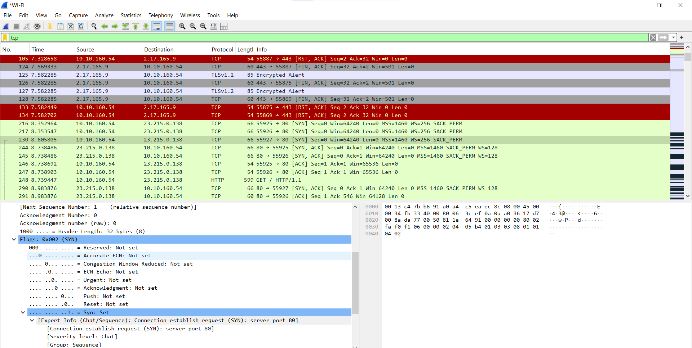

**Description:**

* The client initiates the connection using a **SYN flag**.
* This is the **first step** of the TCP 3-way handshake.
* The source IP is the client’s, and the destination IP is the server’s.
* TCP Flags: **SYN = 1**

🔹 **Screenshot 2 – SYN, ACK Packet**

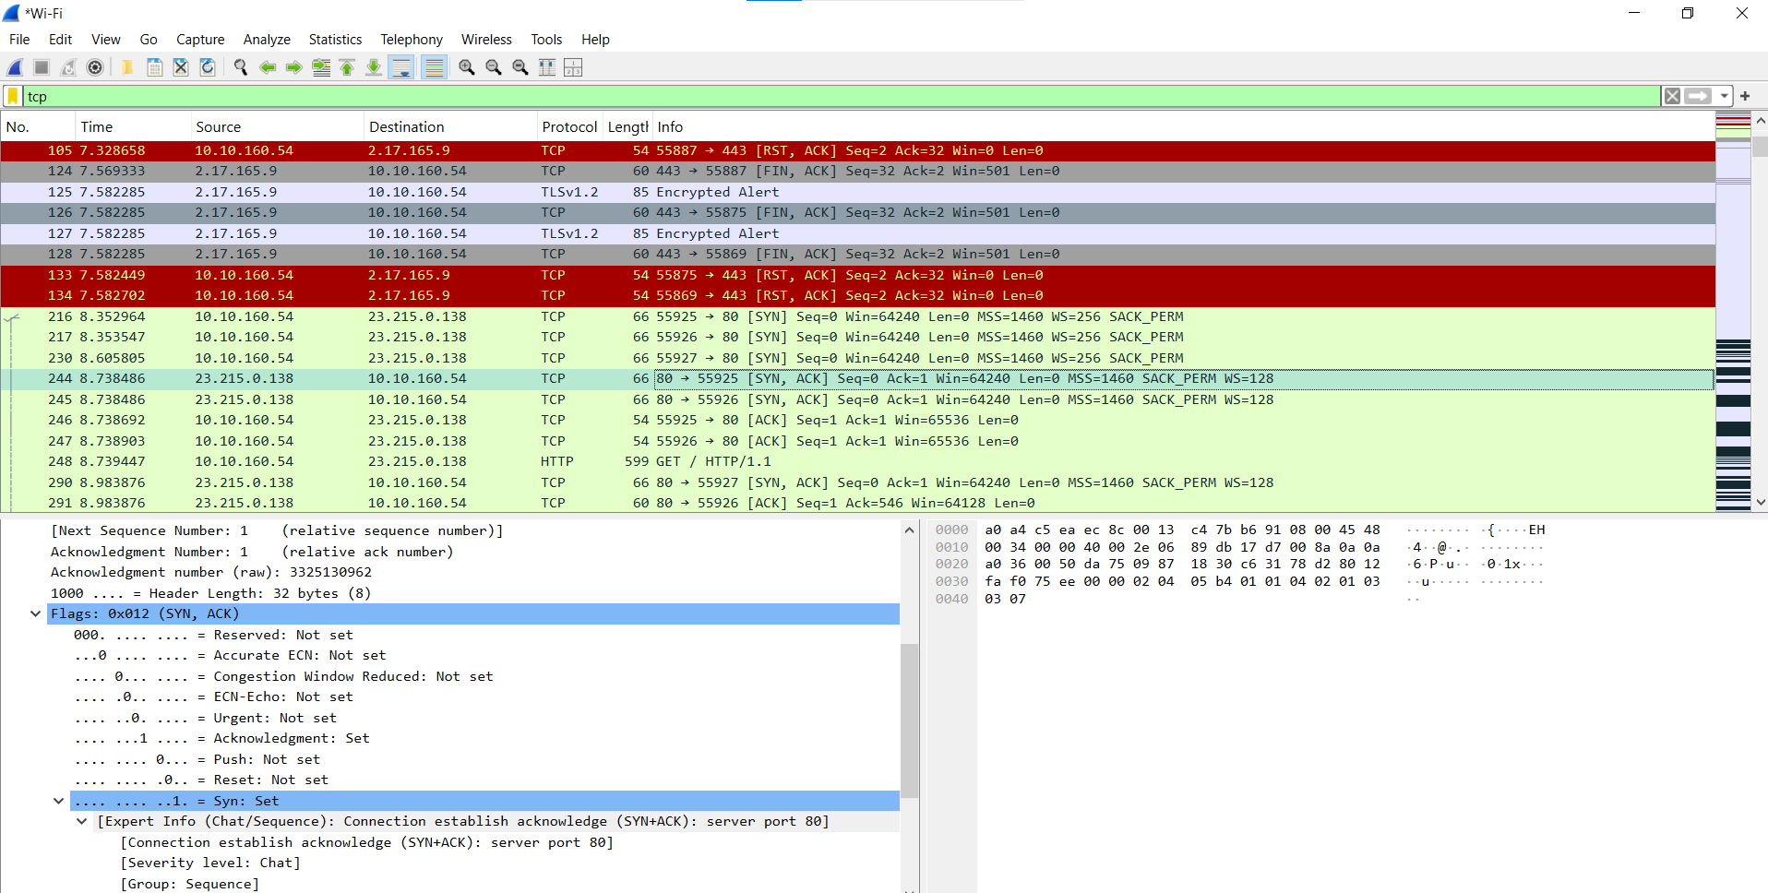

**Description:**

* The server responds to the SYN request by sending **SYN and ACK flags**.
* This is the **second step** of the handshake.
* The direction is reversed: source is the server, destination is the client.
* TCP Flags: **SYN = 1, ACK = 1**

🔹 **Screenshot 3 – ACK Packet**

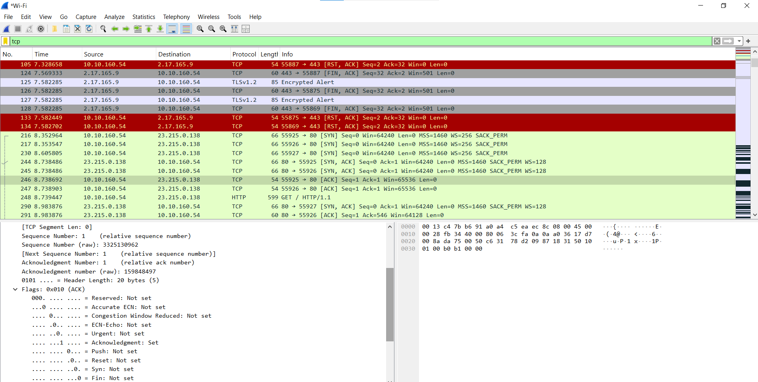

**Description:**

* The client sends an **ACK** back to the server.
* This completes the 3-way handshake.
* TCP Flags: **ACK = 1**
* From this point, data transfer can begin.

### Conclusion:

This capture demonstrates a successful TCP 3-way handshake between a client and a server using Wireshark. Each step (SYN, SYN-ACK, ACK) was captured and analyzed, providing a clear view of how a reliable connection is established on the network.